Test Designer

Definition
# Source: AI Source: Provided by: [Data Path: Persons Table -> ID Column: 1, Name_En Column: Motasem Essam] -> From: [ChatGPT] on [8/22/2025]
A Test Designer is responsible for creating detailed test cases, test procedures, and test data based on requirements, specifications, or user stories.
- Ensures that the tests effectively validate the functionality, performance, and reliability of the system.
- In ISTQB terms, the Test Designer may overlap with the Test Analyst role, focusing on test specification and preparation.

Key Responsibilities
# Source: AI Source: Provided by: [Data Path: Persons Table -> ID Column: 1, Name_En Column: Motasem Essam] -> From: [ChatGPT] on [8/22/2025]
- Test Case Design
  - Develop detailed test cases from test conditions or requirements.
  - Specify inputs, execution steps, and expected results.
- Test Data Preparation
  - Create the data sets needed for test execution.
- Test Coverage Verification
  - Ensure all requirements or user stories are covered by test cases.
  - Maintain traceability between requirements and tests.
- Collaboration
  - Work with Test Analysts / Business Analysts / Developers to clarify requirements.
  - Support test execution teams in understanding and executing tests.
- Review and Optimization
  - Review test cases for effectiveness and efficiency.
  - Optimize tests to maximize coverage with minimum effort.

Skills Required
# Source: AI Source: Provided by: [Data Path: Persons Table -> ID Column: 1, Name_En Column: Motasem Essam] -> From: [ChatGPT] on [8/22/2025]
- Knowledge of test design techniques (boundary value analysis, equivalence partitioning, decision tables, state transition, etc.).
- Analytical skills to interpret requirements accurately.
- Ability to prepare comprehensive test data.
- Familiarity with test management tools (e.g., TestRail, JIRA, HP ALM).

Deliverables / Outputs
# Source: AI Source: Provided by: [Data Path: Persons Table -> ID Column: 1, Name_En Column: Motasem Essam] -> From: [ChatGPT] on [8/22/2025]
- Detailed Test Cases
- Test Data Sets
- Traceability Matrix (mapping requirements to test cases)
- Test Procedures

Shortcut to Remember:
# Source: AI Source: Provided by: [Data Path: Persons Table -> ID Column: 1, Name_En Column: Motasem Essam] -> From: [ChatGPT] on [8/22/2025]
Test Designer = Create detailed test cases + prepare test data + ensure coverage

✅ Summary Note:
In ISTQB terminology, Test Designer and Test Analyst roles often overlap.
- Test Analyst: Focuses on what to test (test conditions/scenarios).
- Test Designer: Focuses on how to test (detailed test cases and data).

Difference between Test Analyst and Test Designer
# Source: AI Source: Provided by: [Data Path: Persons Table -> ID Column: 1, Name_En Column: Motasem Essam] -> From: [ChatGPT] on [8/22/2025]
Here’s a clear explanation of the difference between Test Analyst and Test Designer in ISTQB terms:

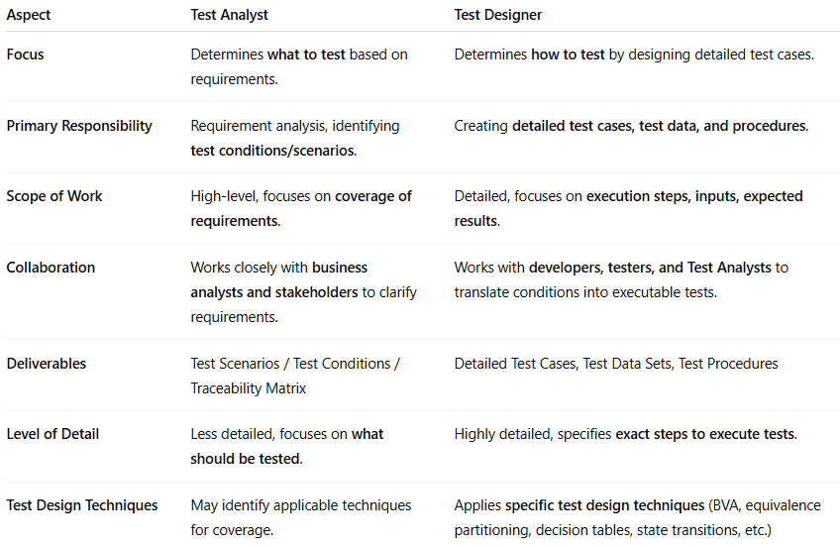
Aspect | Test Analyst | Test Designer
Focus | Determines what to test based on requirements. | Determines how to test by designing detailed test cases.
Primary Responsibility | Requirement analysis, identifying test conditions/scenarios. | Creating detailed test cases, test data, and procedures.
Scope of Work | High-level, focuses on coverage of requirements. | Detailed, focuses on execution steps, inputs, expected results.
Collaboration | Works closely with business analysts and stakeholders to clarify requirements. | Works with developers, testers, and Test Analysts to translate conditions into executable tests.
Deliverables | Test Scenarios / Test Conditions / Traceability Matrix | Detailed Test Cases, Test Data Sets, Test Procedures
Level of Detail | Less detailed, focuses on what should be tested. | Highly detailed, specifies exact steps to execute tests.
Test Design Techniques | May identify applicable techniques for coverage. | Applies specific test design techniques (BVA, equivalence partitioning, decision tables, state transitions, etc.)

✅ Key Point
- Test Analyst = What to test → Focuses on requirements and conditions.
- Test Designer = How to test → Focuses on detailed cases, data, and procedures.
In many organizations, the two roles overlap, and sometimes the same person performs both activities.

